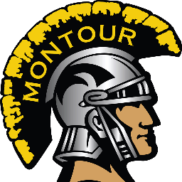
Save the Date! Montour Football Cash Bash – July 25, 2020
Come join us for an Adult Night Out
When: Saturday July 25, 2020 from 7:00 PM – 10:00 PM (Doors Open at 6:30 PM)
Where: Kennedy Township Fire Hall
Drawing every 15 Minutes for Cash Prizes
7:00, 8:00, 9:00 - $250.00
7:15, 8:15, 9:15 - $100.00
7:30, 8:30, 9:30 - $150.00
7:45, 8:45, 9:45 - $100.00
10:00 - $1000.00
Basket Auction, Basket of Cheer, 50/50 and additional raffles to be held.
Free snacks and refreshments (Beer, Pop) BYOB
Must be 21 to attend. One Admission per ticket.
Tickets are $25.00– Fundraising Credit based on tickets sold:
2 tickets - $10 per ticket
4 tickets - $15 per ticket
6 tickets - $20 per ticket
10+ tickets - $25 per ticket
If you are interested in Volunteering, please contact the boosters @ (montourfootball@gmail.com)
We will need ticket sellers and people overseeing the auctions.
We also ask each family to donate items for the Basket Auction, if you can’t donate a whole basket, please consider donating gift cards of $10 or more, Scratch-off lottery tickets, a bottle of wine or spirits for the basket of cheer, etc. All donations are appreciated.

